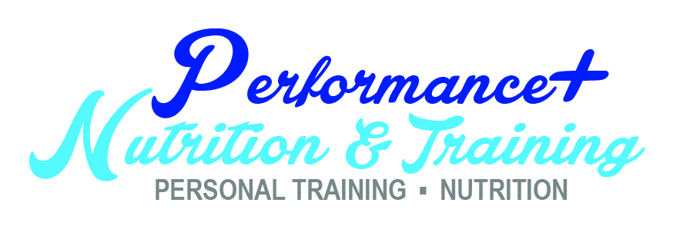
Karen Plum
Certified Sports Nutritionist & Personal Trainer
On Line Coach
2 x Miss Australia/2 x Miss NZ Figure Champion
Ph 0404 728338
kazzaplum@gmail.com

SHOW DAY CHECK LIST

- Suitcase on Wheels to carry everything
- Bikini/costume
- Shoes
- Pump Up band/weights
- Pump Up formula
- Pump Up food – as instructed
- Distilled water
- 2 x Power Aid/Gatorade
- Electrolytes
- Top Coat Tan
- Gloves
- Bikini Bite (make sure going before show)
- Makeup/lip Gloss
- Hairspray/brush/comb
- Eyelashes/glue
- Robe for back stage
- Thongs/sandals
- Number/Back stage pass/tickets
- Jewellery
- Cooking Oil Spray
- Treats for after ☺  
- Knife/fork/spoon
- Rescue Remedy
- Baby wipes/tissues
- Old towel for removing tan/cleaning up
- Safety Pins/sewing kit for emergencies
- A huge smile ☺  

